3.3 I can set up and use access rights to enable others to access information

I was asked to set up a GitHub account so that I could share any work that I have completed with my Tutor. When setting up the account I was asked if I wanted to set it to public or private. I choose to set it to public so that my tutor could access my account without any issues. I chose not to use my real name for my account, instead using an alias for my user name. There is also an option to list your email address, location and social media accounts on your profile which is visible to the public but for privacy reasons I chose not to list those options;

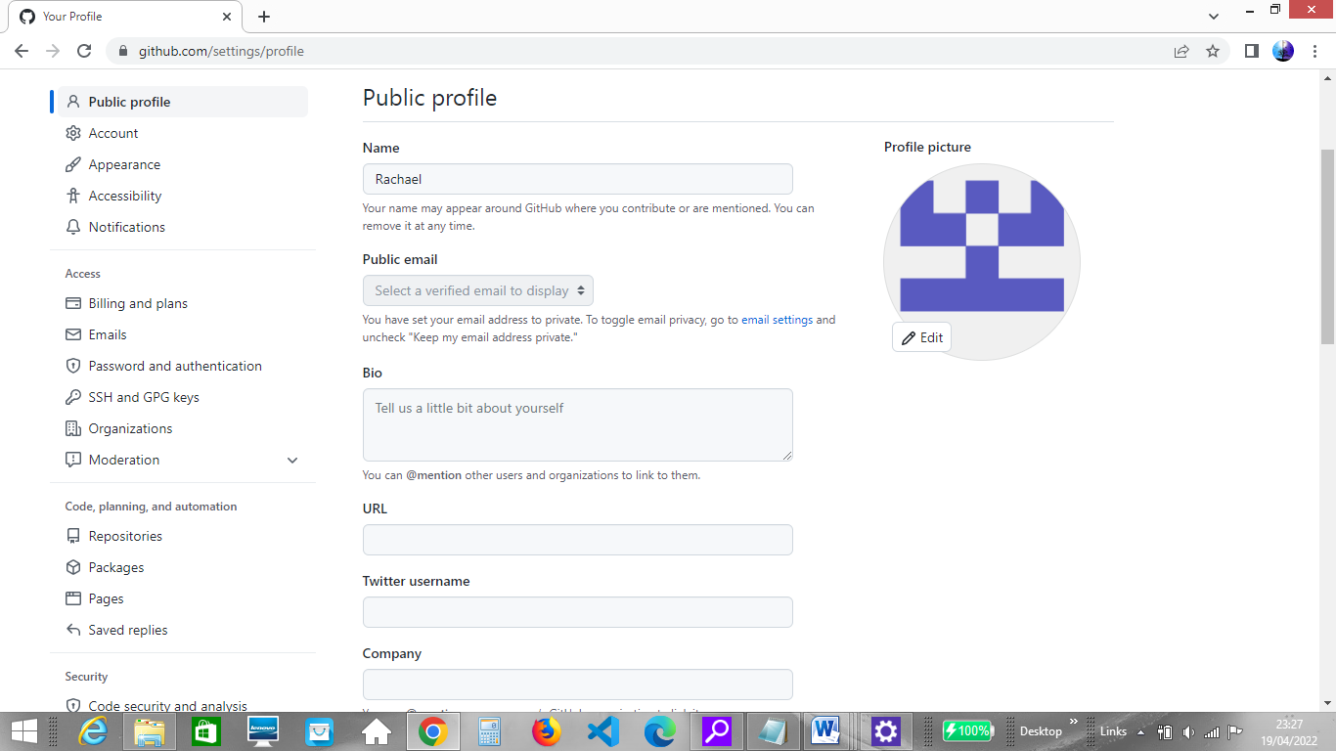

There is also an option to set temporary interaction limits as well as to block users (bottom left);

